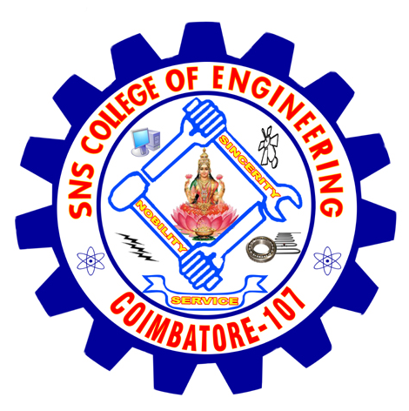
SNS COLLEGE OF ENGINEERING
Department Of Master Of Computer Applications.
Coimbatore – 641 107

MCA 105 PROGRAMMING IN ‘C’

Assignment topics
Unit I
1. Explain with programs Formatted I/O & Decision Making .
2. Explain with programs Looping- While, do, for statements..

Unit II
3. Explain Arrays , dynamic and multi-dimensional arrays with programs.
4. Explain String handling Functions and Recursion with programs.

Unit III
5. Explain basics of Structures, declaring a Structure , Array of Structures, Passing Structure elements to Functions.
6. Explain Union, Union of Structures, Enumerated Data Types, typedef
Statement with examples.

Unit IV
7.Explain Pointers, Declaration, Accessing a variable, dynamic memory allocation with programs.

Unit V
8.Explain Files and Streams , Sequential access file, Random access
file in detail with programs.

Staff in-charge HOD

