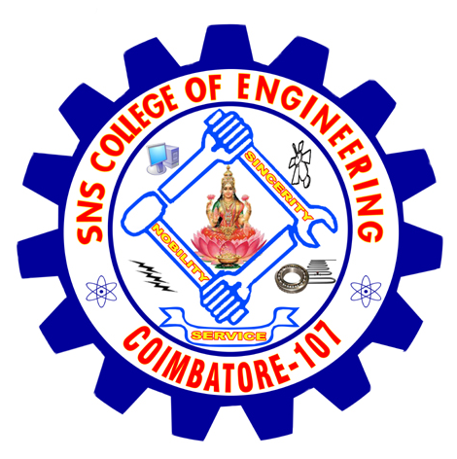
SNS COLLEGE OF ENGINEERING
Department Of Master Of Computer Applications.
Coimbatore – 641 107

MCA 105 PROGRAMMING IN ‘C’

Motivated Study topics

1. A) Simulate following Banking operations using functions.
(i) Deposit (ii) Withdrawal (iii) Balance Enquiry
B) Implement using recursion
(i) Find the solution of Towers of Hanoi problem using recursion.
(ii) Fibonacci number generation.
(iii) Factorial

2. Explain Pointers versus Arrays, Array of pointers, Pointers to functions and structure Pointers with example programs.

3.Explain with example programs Call By Value & Call By Reference?

Staff in-charge HOD

